# Test Document

This document is the software test report of the final testing phase of the CouponSystem software development project.

Input-data: 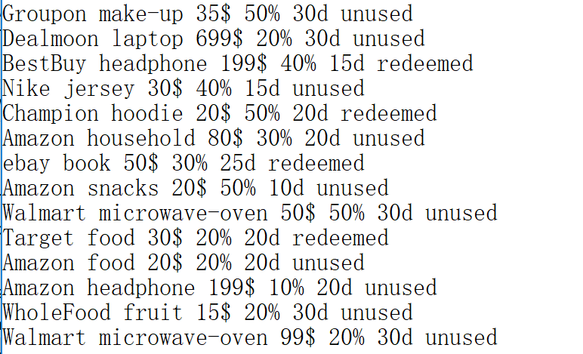

Use these data as user’s original database(that means user-provided data file), we can open the software and read these data as follow:

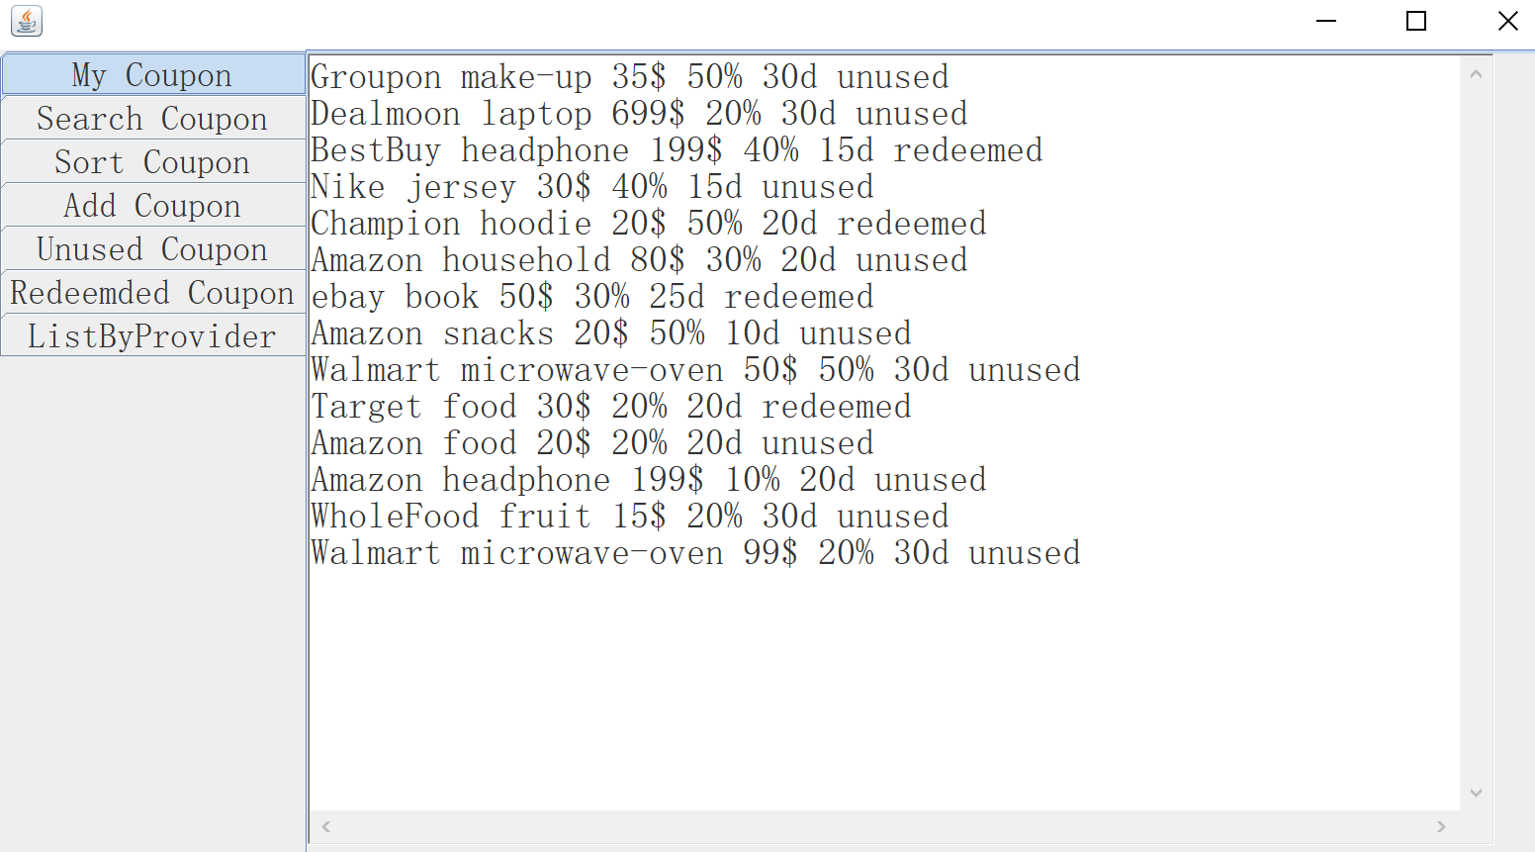

This means io-input and output stream works successfully.

We can text searching function in software:

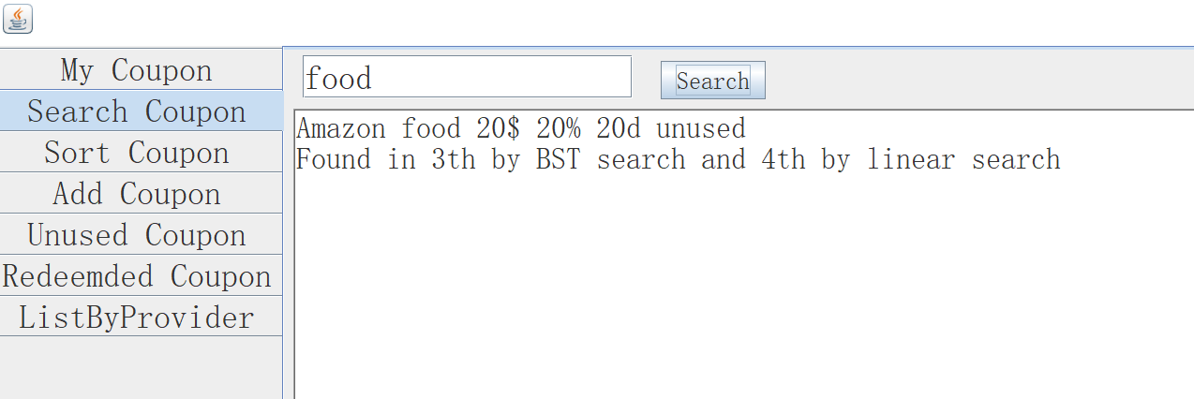

It works and show the time which BST and linear search aglorithms take.